+
Club Visioning
2.0

For Rotary Clubs

Leader’s Guide

July 2018

Contents
Overview 3
Introduction 3
BEFORE THE SESSION 4
Time for Action 4
Writing Exercise 4
Timeline 5
Schedule 6
INTRODUCTION 7
Session Set-up 7
Opening Statements 7
Welcome, Announcements, and Introductions 8
Break 8
THE WRITING EXERCISE 9
Overview 9
Writing Exercise 9
Extraction 10
Flipchart Samples 11
Break 13
DOT VOTING 14
Multi-Voting “Dot Exercise” 14
The Second Round of Dot Voting 14
SUMMARY 16
VISION TO PLAN 17
SMART Goals 17
STRATEGIC INITIATIVES 18
Explanation of the 5 Actions 18
CLOSING REMARKS 20
APPENDIX 22
VISION EXERCISE 23
SMART GOALS 29
Synthesizer Role 30
SYNTHESIS: THREE POINTS OF VIEW 31

Overview
A long-range plan provides the framework for each club’s “Service Above Self”. The simple act of writing down common goals builds camaraderie and fosters agreement. This renewed focus on objectives naturally pushes clubs and districts towards action. A Club Visioning session provides a shared Vision for the future, and builds the foundation for a written plan that promotes consensus, consistency, and continuity.

Introduction
Rotary leaders recognize the crucial role of effective planning for Rotary club success. Many clubs and districts have participated in a Vision Facilitation or equivalent program that helped them define their missions, strengths, challenges, and especially, priorities. Such programs promote and include the necessity of follow-up action plans.
A Vision process is intended to galvanize participants into Service Above Self.
The goal of this Visioning program is to assist clubs to define themselves and their priorities.
© 2018 International Vision Facilitation Council, Inc.
All rights reserved. No part of this presentation may be reproduced, stored in a retrieval system, or transmitted in any form or by any means—electronic, mechanical, or any other—without the prior permission of the International Vision Facilitation Council, Inc.

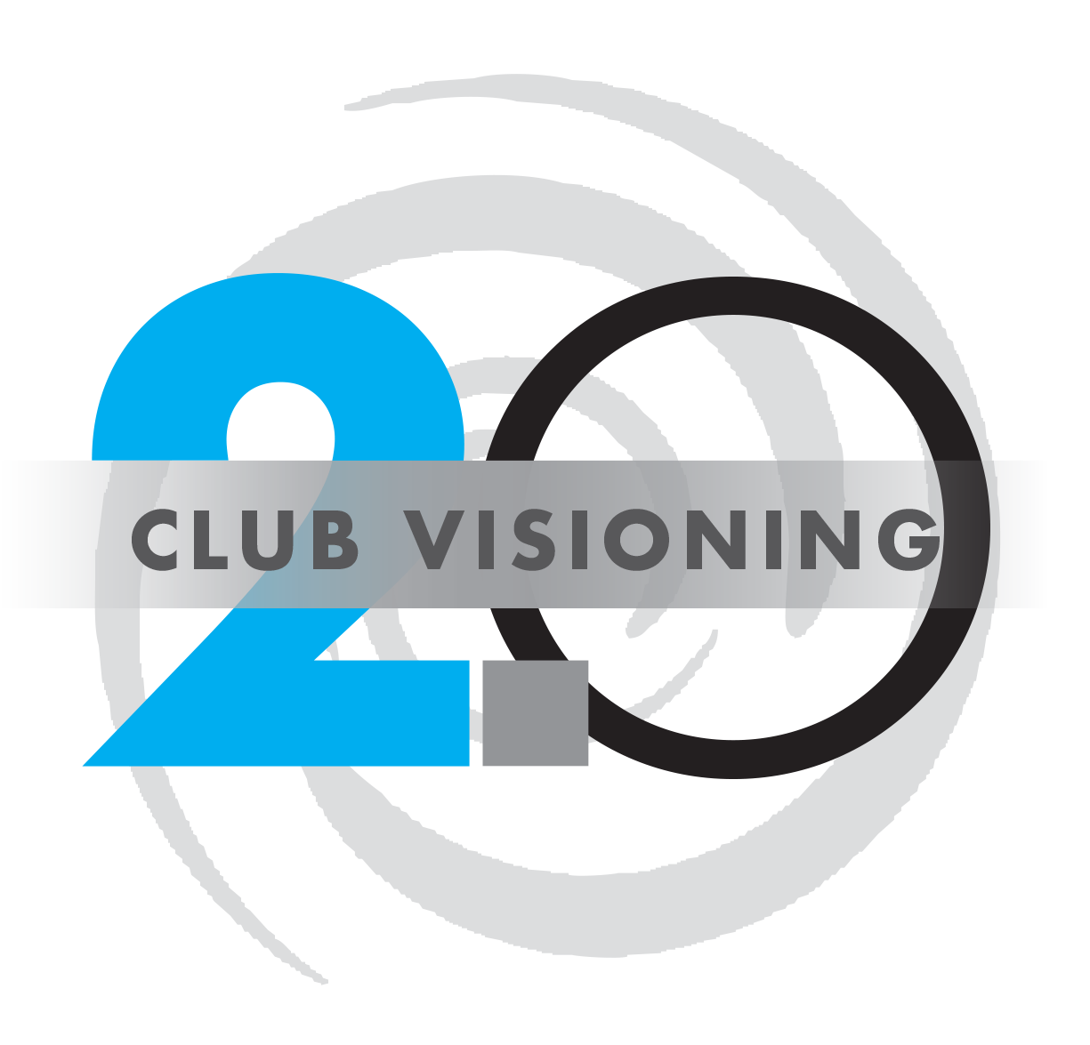
BEFORE THE SESSION

Time for Action
Clubs can benefit from basic strategic planning concepts in a straightforward Visioning for Rotary Clubs procedure, led by a small team of non-Club-member District leaders in a program of approximately four hours. Such a program will help the club define their own priorities.

Writing Exercise
This occurs before the club has completed the Visioning process, or equivalent. This session may be conducted electronically if desired. Allow 60 minutes.
Optionally, this exercise can instead be added to the visioning class, extending the duration by 60 minutes.
The Rotary Club requesting a Vision Facilitation Event will identify a “Club Vision Event Coordinator” that will coordinate the entire event before any event planning activities begin and provide requested visioning outcomes back to the District Vision Team.
The District Vision Coordinator will establish contact with the Club Vision Event Coordinator to set the date for the facilitation event and outline club expectations.
Club Vision Event Coordinator Guide, Pre-session Club Profile form, and FAQ’s are downloaded from the District website 3-6 months prior to the event so that the club understands the process and begins working on the timing of the event.
The Rotary Vision Questionnaire (RVQ) is sent to all vision session attendees 4-6 weeks preceding facilitation with the expectation that the results are sent to the facilitation team 1-2 weeks before the scheduled facilitated event.
Rotary Vision Questionnaire (RVQ) information is collected by the Vision Team Coordinator and a summary of results sent to the Vision Team facilitation.
The Club Vision Event Coordinator will supply the District Vision Coordinator with details (# of participants) and directions to the site of the facilitation a minimum of 1 week prior to the Vision event which is then distributed to facilitators.

Timeline
Date | Days from Event | Description
03/01/17 | 120 days before | Discuss Visioning Event with District Coordinator and Club Coordinator. District coordinator explains how to coordinate the event.
04/01/17 | 90 days before | Confirm Club is ready to Vision and finalizes an event date.
05/01/17 | 60 days before | Invite club members to participate. Important to include President, PE, PN, past leaders, and a mix of old and new members. Most clubs should invite 15-30 participants, with the ideal being 18-23.
05/15/17 | 45 days before | RVQ is sent to all participants. Club coordinator provides the list of participants.
05/22/17 | 38 days before | RVQ reminder is sent to all participants who have not yet responded.
05/28/17 | 31 days before | Visioning coordinator reaches out to participants who have not responded to the RVQ.
06/01/17 | 30 days before | Benefits of Visioning/Planning presentation given at the club. This is performed by a District Visioning team member, or an AG. A draft is available on the IVFC website.
06/08/17 | 21 days before | President has 2-3 members talk about why they joined Rotary, and why they stay.
06/08/17 | 21 days before | Writing exercise is distributed to participants.
06/14/17 | 14 days before | District coordinator confirms with Club Coordinator that we are on track and ready to go.
06/14/17 | 14 days before | Club president has someone present a list of past service projects and fundraisers.

Schedule
Start Time | Duration | Description
7:30 AM | 30 minutes | Arrival and Setup
8:00 AM | 15 minutes | Eat meal
8:15 AM | 15 minutes | Introduction, rules, and agenda
8:30 AM | 5 minutes | Clean up mess
-- | 60 minutes | Optional Writing Exercise
8:35 AM | 85 minutes | Extraction
10:00 AM | 10 minutes | Break
10:10 AM | 35 minutes | Dot Voting
10:45 AM | 30 minutes | Summary
11:15 AM | 10 minutes | Vision to Plan
11:25 AM | 15 minutes | Group Exercise - Strategic Initiatives
11:40 AM | 10 minutes | Closing Remarks
11:50 PM |  | End

INTRODUCTION

Session Set-up
Arrive with your training team 30+ minutes before the start of the session to begin setting up the materials
- Verify your team has understands their roles:
  - Vision 2.0 Team Leader (as presenter)
  - District Visioning Chair/Committee Member (or equivalent; speaker and assistant)
  - Club Coordinators
- Club provides tent cards with names and roles of each participant on each side, to be placed on tables.
- Prepare signage to help participants navigate to the correct room
- Print a copy of the Handouts for each member
  - Print 10% extra (or 3 extra, whichever is larger) to allow for the unexpected
- Use a format that allows people to see each other
  - Round tables help with the small-group activity during the session
  - A U-Shaped setup allows everyone to see everyone else, encouraging discussion
- Plan where wall charts will go
- Prepare and test the technology setup; do a quick run through your materials to verify everything is ready
- If a meal is planned, participants should arrive 15 – 30 minutes before start of session, get food, and get ready
  - Avoid heavy or sleep-inducing foods
  - Avoid alcohol until afterward!
- Maximum of 4 hours for the planning session

Opening Statements
Draw out from the group the terms...Continuity/Consistency/Consensus. Review the importance of each with your own supporting examples or anecdotes as to the value of this planning Triangle. On the flip chart, draw a large equilateral triangle. Label the diagonal lines as Continuity and Consistency. The remaining term—Consensus—should be deliberately placed at the BASE of the triangle. It becomes visually obvious as to why this is a group undertaking and will be highly participative during the course of the evening.
The Club Vision Event Coordinator will introduce the Facilitation Team and the lead facilitator will welcome everyone. Allow 5 minutes.
The lead facilitator will quickly give an overview of the evening’s event and what will happen. “Excited to be here and help facilitate your club vision event…”
“We like to offer up three key concepts to think about as we go through the planning process. They all began with the letter ‘C’.”
This introduction can include a directive by the facilitator to “take a moment to clear your minds of the clutter left in your brains from your busy day” (i.e. work, family, things to do).
“There are only 5 questions that we need to answer when engaged in planning. Whether we are laying out the long-range plans for our own organization or wondering about the next family vacation, there are 5 things we should want to know, namely…
- Who are we?
- Where are we”
- Where do we want to be”
- How will we get there?
- How will we know when we have arrived?
Today, our vision session will focus on only one of the questions – particularly, number 3. Where do we want to be?
We already have the answer to the first questions: Who are we? We are a Rotary Club chartered in ________. We have ______members. We can describe our general demographics as ______(average age), ______(gender mix), ______ (median years of membership) and the like.
Also, we know “where we are”. The community we serve is ______. Our dominant programs include_____. We know the dollars we spend are ________.
But today we are tasked to answer...Where do we want to be? And to facilitate and expedite your response to the question, we will have you imagine and describe “your club…not as it is, but as it has become”. To look three years into the future and see how things are in the year ______.”

Welcome, Announcements, and Introductions
Have your team personally introduce themselves to participants. Allow 10 minutes.
Open with brief explanation of process and agreements for session - one conversation, everyone participates, etc.
Prepare the Club Vision Event Coordinator or the President in advance with a small script as to how you wish the individual to introduce your team to the participants. This should take less than 5 minutes and is done as soon as all members take their seats.
Next, efficiently go around the room, making the tenure inquiry of each participant as a form of “ice-breaker.” (Even members of the same club may not know the longevity of their fellow Rotarians.) Ask their role in the Club as well. Specifically look for Past Presidents, President Elects, and President Nominees. Then take a marker and write these titles on their name cards. This will help you remember later during extraction.
By virtue of the responses, you will be able to:
- Discern how “deep” individual experiences are
- Vary any subsequent explanations and examples of Rotary programs or activities to match the experiential level of those present
- Identify the most experienced members for any counsel and advice they can bring to the requisite Action Plans that later conclude the session.

Break
This is a short bread to clean up after the meal. Allow 5 minutes.

THE WRITING EXERCISE

Overview
Discuss the Writing Exercise to the participants, and explain the Extraction process. Allow 10 minutes.
You were sent a writing exercise ahead of this event to help spur your thinking about the future of this club. Do you all have that with you? Let’s now take your thoughts and share them with the group, and get them up on the wall so we can peruse them as a group.
“You were asked to imagine the future—to place yourself 3 years from today and look back on the success of your Rotary Club. You were asked to ‘see’ your club not as it is, but as it has become.”
Relevant and inspiring quotes can be incorporated. Consider...
Dreams get you into the future and add excitement to the present. (Robert Conklin)
Your hopes, dreams, and aspirations are legitimate. They are trying to take you airborne, above the clouds—above the storms—if you only let them. (Henry James)
Vision is the art of seeing things invisible. (Jonathan Swift)
If you reach for the stars, you may not grasp one. But you’ll not come up with a handful of mud either. (Anonymous)

Writing Exercise
This section is optional. If the Writing Exercise was completed ahead of time, skip to the Extraction. Allow 60 minutes.
During this session we will bring together a broad-based group of club leaders, including the President and President-Elect. During this session, working from an outline writing exercise, a facilitation is conducted and ideas from the club leaders are drawn out during the extraction.
Example Topics:
- Membership
- The Rotary Foundation
- Avenues of Service
  - Youth Services
  - Vocational Service
  - Club Service
  - Community
  - International Service
- Leadership Development
- Young Professionals

Extraction
The Extractor pulls thoughts from the room, while keeping the discussion vibrant and positive. Allow 75 minutes.
“Extractor”: Thoughts will be recorded using two scribes who will be alternately writing paraphrased notes on the post-it flip charts. The “switching off” between scribes is to save time. The extractor plays a pivotal role in harnessing the “feedback” from the members, drawing out their thoughts, and helping the scribes to paraphrase when needed. Extractors must instruct the group to only speak one at a time and to respect the response of the individual talking. Extractors should also explain to the group how we are looking for your written ideas, but delivered as a headline or sound byte. The extractor then works in conjunction with the scribes ensuring proper pace and content interpretation. They repeat and/or summarize ideas to help the scribe in writing. They are the ones who continually suggest participants rephrase their ideas into a tighter, shorter statement. The process of drawing out the feedback will mean that the scribes are trying to grab the concept in the least number of words and then writing them on the flip chart. When your participants get excited about certain subjects they will start talking quickly and on top of one another...you as the facilitator MUST manage this so the scribe has a “writing” chance.
Scribes should use blue and/or black markers to record (please reserve red markers for the synthesizer role).
The next part will be the collection and scribing of their written points for each of the areas of the written exercise. Facilitators will not ask them to prioritize or discuss/debate anything at this point. This is not a brainstorming or discussion session. Members simply share with the group what they have written for each of the exercise questions. Collect this information on the flip charts ONE TOPIC at a time. The scribe will put a heading on the top of the flip chart for the area you are collecting...
In other words the first flip chart (place a #1 in the upper right hand corner) will be titled “Club Stands For” in the community. You as the facilitator will go around the room asking each participant for what they view as what their club stands for in their community... Avoid starting at one end of the room and moving on to the very next person. Ask for input from various people on all sides of the room without following the “line-up” approach. Keep filling in the flip charts with headers and numbers until you have captured everything on the participants’ exercises. The purpose of the written exercise is to have each member INDEPENDENTLY write down their perspective of their club; this is NOT a group fill-in. Once you have gathered all of the feedback on the flip charts the exercises can be thrown away or the respondents can keep them. The objective is to get the information independently created and group collected (all within your allotted timeline).
Where available, have a runner (who may be an extra team member, an AG, or someone who has come to observe) post the wall charts in order around the room.
During or at the conclusion of the extraction/scribing, a “best practice” is to utilize a brightly colored masking tape (painter’s tape is recommended) to delineate between each category on the room walls. This will enhance the Dot Exercise which follows.

Flipchart Samples
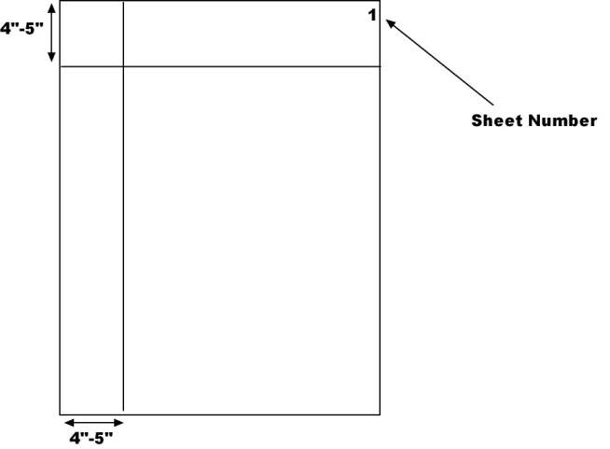
During the writing exercise (while the club is busy) prepare about 20 (10 on each tripod) 3M Post-It Wall chart sheets on each for the scribing portion. Each sheet should have the crossed lines and be numbered alternating from one easel to the other as represented in Figure 1.
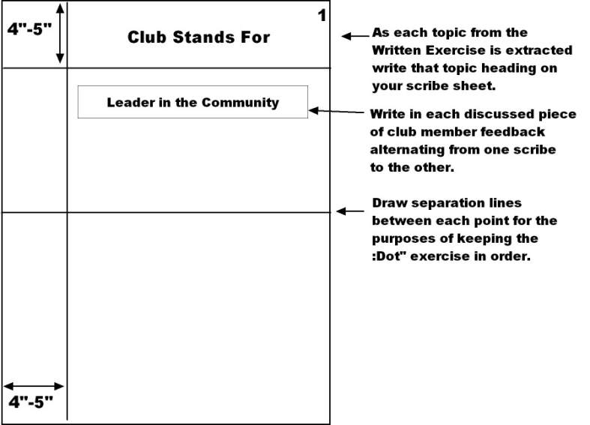
Consolidate any duplicates in a category (or when we are gathering the original feedback just note that “the response is similar to this earlier one are you OK with that?”) For the Club Size flip chart (which only gets one dot vote), take all of the responses from the participants as to club size on the right side of the page and re-write them in descending order from the smallest number to the biggest on the left.
This sheet is only voted on once in the first dot round.
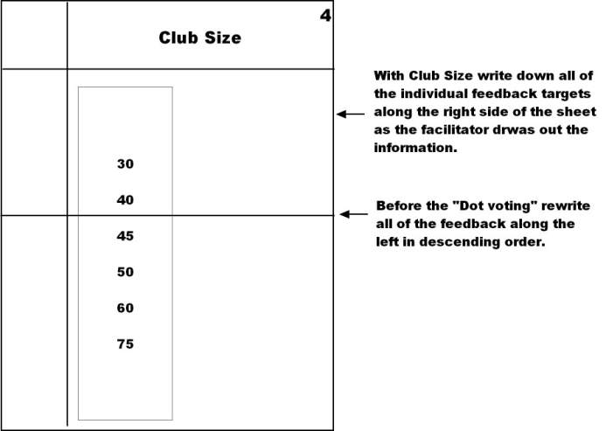

Break
A quick break to stretch and unwind. Allow 5 minutes.

DOT VOTING

Multi-Voting “Dot Exercise”
Each participant is given their first set of dots. They vote based on each category. Allow 15 minutes.
Now distribute the blue dots for voting. Explain that they will be voting with these dots and will be voting for their top choices in each category, utilizing the number of dots you have noted at the top of the post-it sheets. They may place only one dot to a line and the dot will be placed to the left of the statement (where your line created a box)...stacking of your 3 dots on one line (voting 3 times for one idea) is NOT allowed.
The objective of voting is to distill the myriad of ideas down to the top 3 in each category, possibly the top 5 or 6 in the service area. It usually takes 2 rounds to accomplish this: the first round distills down to 6-7 ideas and then the second round distills down to 3-4.
Suggest that the session members split up and a small group will stand in front of each category of wall charts (i.e. don’t all start on the same chart). Then as the dot voting begins, the small groups will ALL move clockwise around the room to avoid forgetting which category/area they have yet to place their dots. This is not the time for a person to take a break and leave the room.
Here are categories and the dots required:
- Vision Pursued/attributes…………………………………… (4 Dots)
- Club size……………………………………………………………. (1 Dot)
- Club Administration/Leadership…………………………. (4 Dots)
- Avenues of Service……………………………………………… (6 Dots)
- Club Fundraiser…………………………………………………. (2 Dots)
- The Rotary Foundation (and Club Foundation)…….. (2 if only TRF, 4 if Club Foundation also)
- Public Image & Awareness………………………………….. (3 Dots)
Total dots to handout 24 Dots (22 if no Club Foundation)

The Second Round of Dot Voting
Each participant is given their second set of dots. They vote based on each category. Allow 15 minutes.
Following the first round (Blue round) of voting the facilitation team will take their markers, walk around the room identifying those statements that did not receive many dots. They will X out the voting square adjoining any statements to reduce the choices to 5-7 elements per Vision category, and 8-10 in the service area. The Voting Facilitator will then distribute the Red dots for the second round instructing all participants that they can only vote on topics that do not have an X of elimination on. The same voting procedures are used for the second round…nothing changes, except for the fact that you cannot vote for anything that has an X on it.
The reason for the second round of dots is that we eliminate all statements that received zero to a few dots on the first round. This process tends to really narrow down the focus for the future of the club resulting in the top strategic initiatives.
Note: The categories that may not need a second round of votes are club size and fundraising. This will be determined by the Voting Facilitator once the first round is completed. If the dots seem to be falling into 1 very specific number with few dissentions, then there is no need for a second vote. If a smaller group is being facilitated, a second round may not be needed. For example, under the foundation category, a small group may only offer 4-5 ideas.
Guiding principles proposed for the Multi-voting exercise:
- Use consistent process for each group, regardless of the number of participants (this will be as valid as any other approach)
- Use the same number of dots for each category for each of 2 rounds
- Too many dots per category will slow down the process and not improve its value - the idea is to get consensus around which are the ideas most worthy of further work when there is no one clear “best”
- Use the specified number of dots for each category. This gives us enough input to do our synthesizing based on clusters of dots, and gives the Club enough focus to take next planning steps. This dot process will accommodate groups of 10-12 or 20-25.
- The objective of the first round of voting is to bring the number of stated elements from whatever was posted on the wall charts down to 5-7 (8-10 for service) elements for the second round. Put an X over any elements that will be eliminated in the dot voting box to limit the choices on the second round to 5-7 (8-10 for service).
- Sometimes you get consensus on the first round of voting, so that area does not require a second round. Adjust the dot voting accordingly in the second round of voting.
- No “voter” may place more than 1 dot on any option/idea in each category
- Have people split up and start facing one of the categories of wall charts. Then everyone shifts to the next category of wall charts moving in a clockwise direction.

In the synthesis that follows, look for options/ideas that might be combined or blended because they are related.

SUMMARY
The breakdown of Categories to strategic initiatives - Drawing Conclusions and Summarizing. Allow 30 minutes.
Go to each of the areas, count the second vote of dots and identify the top 3 or 4 vote getters (5-6 in the service area. With a different color marker than used by the scribes (red), underline the key words. The synthesizer will then give a verbal report on the top vote getters (circled) for each area.
The synthesizer quickly (and with energy and passion) connects key statements from the various wall charts to show any interrelated ideas. The synthesizer also makes observations as to what seems to be “evolving” (trends or similarities) out of the voting. Some clubs begin to show a pattern, theme or a type of club characteristic that simply “pops” out. A good synthesizer will begin to catch on to this. This is where the excitement increases for most participants and some will offer up some “Ah ha’s”! If the excitement catches on, some small groups or individuals may even start to formulate their elevator speech on the spot.

VISION TO PLAN
This sections shows the club how to start acting on their new Vision, and introduces the concept of SMART Goals. Allow 10 minutes.
Everyone here came because they know how great your club will become, and they want to be a part of that process.
By setting goals, you make your Vision a reality. Starting with strategic initiatives, what are our first steps towards realizing your Vision, and how do we follow-through every day?
SMART Goals breaks down your strategic initiatives into well-defined tasks that can be assigned to each club member. Through the SMART Goal process, you move from WHAT needs to be done, into HOW you achieved it, through accountability and well-defined strategies.
Remember that our goal today is not to define your Club’s goals, but to teach you how to derive those goals from your Club’s Vision.

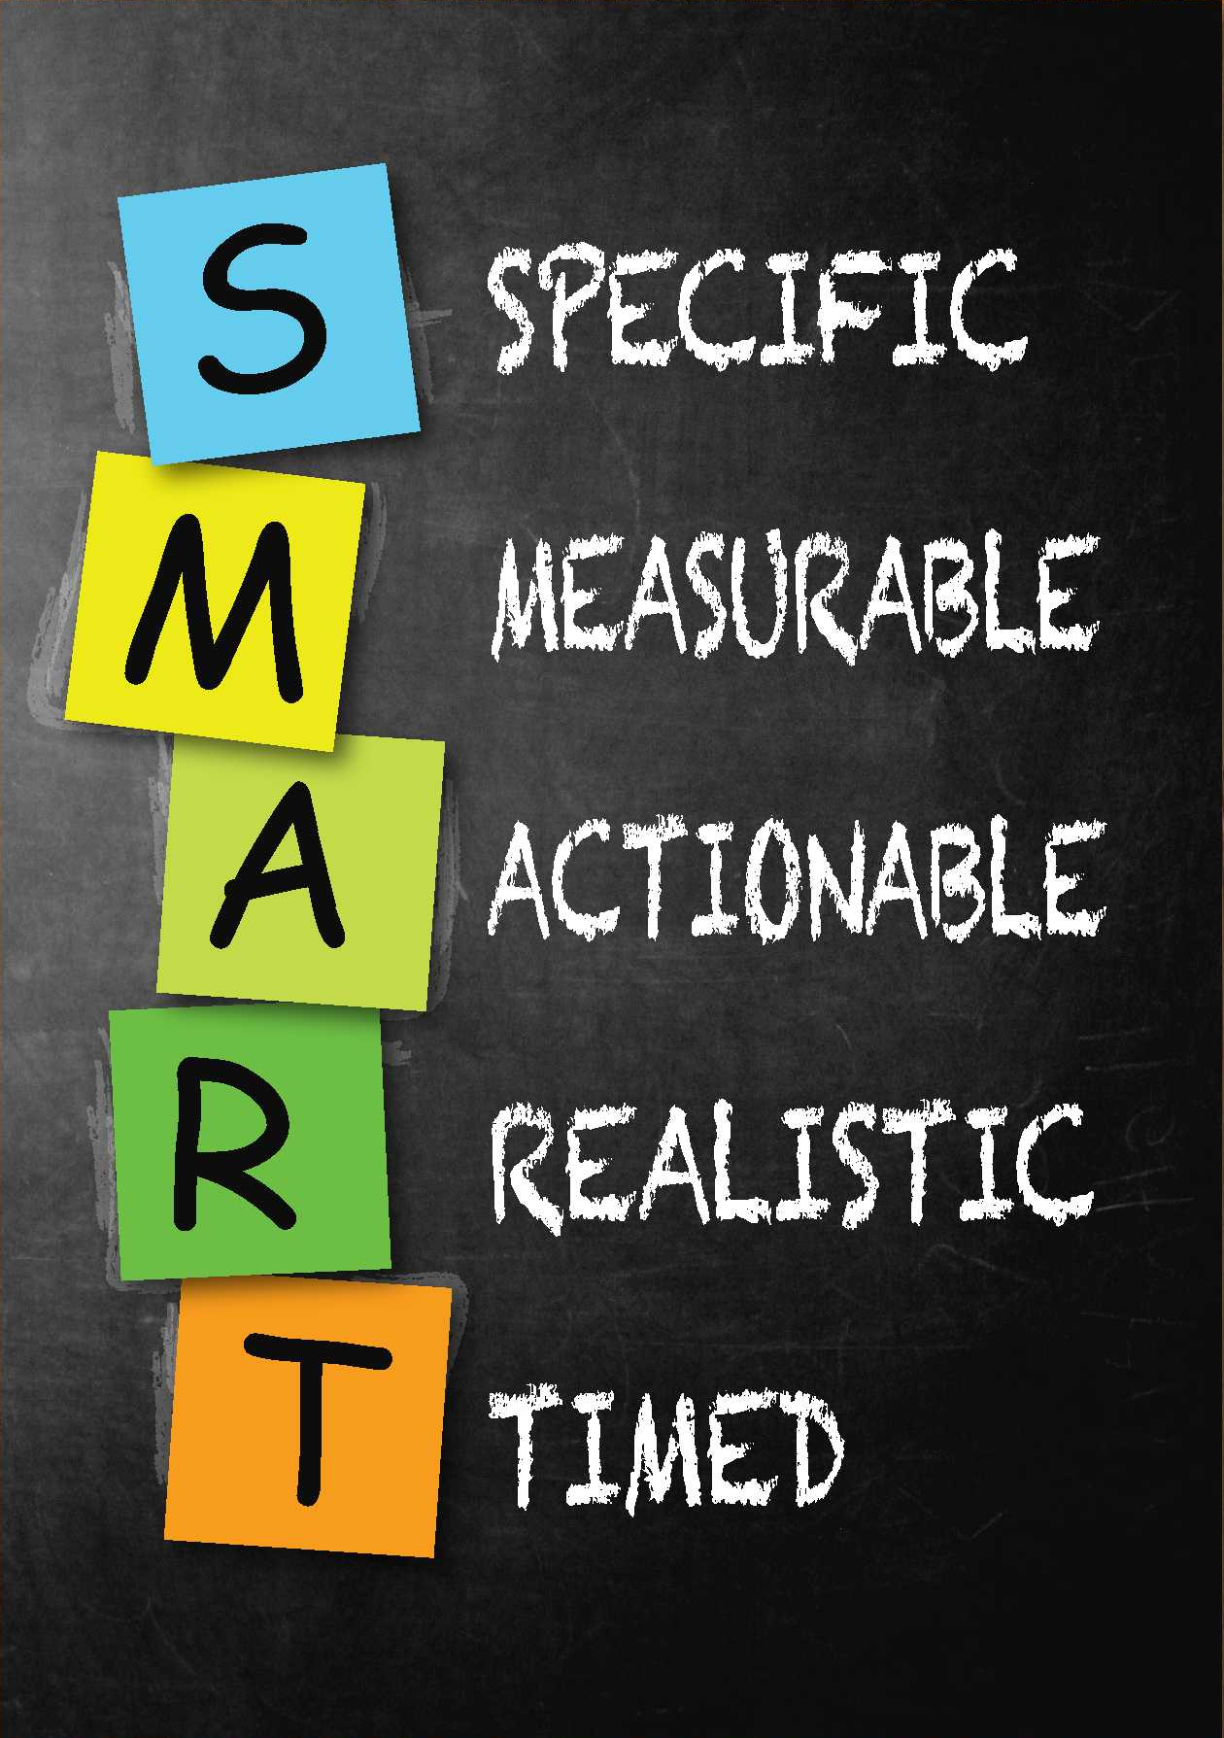
SMART Goals
Some of you may be familiar with SMART Goals from your business or personal life. We are going to explore how to apply these concepts in the Rotary world. It is important to understand what a SMART goal is. This is the heart of your plan. Your visioning plan has strategic initiatives, and your leadership has chosen the top 3 – 4 strategic initiatives. The flip charts from those initiatives will help you create the top 2 or 3 goals for each. Then you will write those goals as SMART goals.
- Specific – who, what, where, how
- Measurable – can use a quantifiable metric or observations of progress
- Actionable – is a goal that we can act on
- Realistic – is ambitious but achievable
- Timed – has beginning and end dates

STRATEGIC INITIATIVES
This sections shows the club how to start acting on their new Vision. Allow 30 minutes.
The next steps are rather straightforward and are actually established even before the session begins. It all boils down to handful of very important documentations and presentations. Keeping it simple allows the Club to come away from their newly found “Vision” with enthusiasm and excitement without that dread of taking on more and more tasks just to get it implemented. The club can embrace their vision and later, after finishing up their handful of actions, move on to the more detailed creation of a more formal strategic plan listing many tactical actions. This is an option for any club to consider.
These are the 5 proposed actions that must result from this facilitation.

ACTION | WHO | WHEN (Specific Date)
- Compile the facilitation wall charts and populate the website with info | John, our club secretary | 2 weeks using the facilitation team provided Excel template
- Create a Statement of Purpose for our club using the information gathered this evening. | Mike, Jenny and Sue | 3 weeks (in preparation for our club assembly)
- Schedule a club assembly to share what has happened, engage the balance of the club and gain consensus | President Steve | Upcoming Quarterly Club assembly in 5 weeks
- Continue developing the “action steps” for a Vision to Plan | Past-President Connie | Next month and once a quarter there after
- Choose a Club Vision Champion | Influential leader Joe | Ongoing

Explanation of the 5 Actions
- Compiling the Wall Charts into a Summary: The compilation of the many ideas posted on the walls during the vision session should be done rather quickly, while it is fresh in everyone’s minds. With the spreadsheet templates provided, an individual will find it easy to transfer. The Focus Areas are then entered into the website so the club can track their progress.
- The creation of a Statement of Purpose (“elevator speech”, slogan, mission or vision statement) is very close to the establishment of a club mission. It basically explains why the club is in existence today, what the club stands for in their community, and shares the unique “personality” the club represents. If It does not fit the personality of that particular club it will offer less meaning to the members. Overall, it becomes the new rallying point around which this club can make decisions, recruit, and offer services. Because of the enthusiasm that came out of the vision consensus process, this writing exercise must be done within the next 2-3 weeks and by individuals who experienced the session’s excitement.
- Scheduling a club assembly or forum may be a new concept for some clubs. It is important to take the time to explain why this is an important action a club should undertake. Ideas that are not written down simply remain ideas (and dreams). Once ideas are documented, it is easier to remember and easier to communicate to others. Once communicated and explained to others, it is easier to gain understanding and buy-in. And once a club gets buy-in, the club gains consistency, continuity, and an extended consensus. At the grass roots level, written “intent” pushes accountability. It is hard for a club to publicize something they never intended to follow through. With this in mind, a catalyst for pushing this forward is to create an event (with a set date) where the vision and actions can be shared with the rest of the club, proudly, with enthusiasm, and with style! We have found that if this is not done within 4-6 weeks from the vision session, the excitement dies down and the daily tasks of current reality take over.
- Setting a date for the Vision to Plan training is critical. Clubs who are able to take their focus areas and then create structured plans to accomplish them have an infinitely higher likelihood of success.
- Why we need a club vision champion: Effective implementation of the club vision plan requires club consensus (which is accomplished at the vision session). A champion ensures that progress is made and the actions incorporated into the workings of the club. The role of the “owner” of the club vision plan is to ensure the vision created at the session is in the forefront (top of mind awareness) as club leadership discusses annual goals and tactical projects throughout the year. While all club members are responsible for creating and helping to execute the actions and represent the new slogan, the club vision plan owner is the chief advocate to make sure progress is tracked, documented, and that the plans are actually being implemented. This champion documents any changes, updates them and serves as the point person for the AG and visioning team for further communication. If the club determines that a strategic committee will further develop strategies and tactical actions, the vision champion communicates directly with this committee and helps to support their efforts.

CLOSING REMARKS
Thank the participants for their attendance and participation. Recognize that they have given their time and energy to create a focus for the future of their club, and in doing so have an impact on the future of their community. Allow 10 minutes.
Any of these statements/explanations can be used by a facilitator when closing the session.
“This (name) Rotary Club team has accomplished a tremendous amount tonight. In about 4 hours you have brainstormed and reached consensus on a set of priorities for near and long term action in each of the club’s service areas.
It can, and should be,
A platform for communicating with the whole club about the work you have done here,
- What it means as a platform for short and long term strategic and action plans
- A way to help ensure continuity and consistency of focus and action out into the future
- A recruiting tool. When all members can passionately and succinctly state what the club stands for and where it is going, recruiting becomes simply sharing the opportunity to participate
  - A press release should be issued to the community. Now that this club has seen a vision, there is a good chance that others within the community would like to be a part of this vision”
“As we close this session, let me ask you two questions:”
- What doubts, worries, concerns, or reservations do you have about this evening’s discussion of strategy? [Listen to responses]
- What excites or energizes you most about this evening’s discussion of strategy? [Listen and affirm responses]
“When you look at all of the activities that have been posted around the room, remember that not all will be accomplished in one year. For instance, (pick a topic)…year 1 may be researching what others in the community are doing in this area, year 2 may be working with the school officials, with a plan to start in year 3.”
“Rotary clubs doing work in all 4 avenues of service are well balanced clubs. For instance, if you are only doing community service, then you may well be similar to any service organization here in this area. A strong Rotary club is not only active locally, but is active in other parts of the world, and is active in bringing the world to this community.”
“When you have a plan it should make it easier for members to step into roles of leadership. Once they are aware that they don’t have to figure out ‘what will I do in my year in leadership?’, but that they are the steward of a long range plan, it should make it more enticing to volunteer.”
“Once you have had some time to work on Assignment Step #2 (mission, vision), I strongly suggest that you issue a press release. The press release would tell the community that the Rotary club has come together and will be working in the following areas in the years to come. Chances are good that there are people in the community that have interest in those areas and might be looking for an opportunity to work with or join a group with the same vision.”
“We are often asked “How do we compare to other clubs?”. Of course there are some commonalities between clubs, but it is always exciting to see the wall sheets completed because they reflect the culture of this club, and the culture in other clubs really is different.”
“You have put up many great projects on the wall tonight. This absolutely ties back into your membership goal as you will need many people to accomplish these goals.”
“Congratulations on choosing to attend tonight. In doing so, you have chosen to help ensure a stronger Rotary club here in this community. When you chose to help strengthen your Rotary club, you also chose to have an impact on the future of this community. And so I applaud your efforts to make a difference for the community of ______. “
“In the very near future a member of our team will be sharing with your club a few tools that will help you move forward including a sample assembly presentation and vision to plan template.”

APPENDIX

VISION EXERCISE
“The Club, not as it is, but as it has become…”

The President of Rotary International is personally inviting you to submit your Club for the first ever Distinguished Club Medallion for extraordinary service. The RI President will present only three clubs in the entire world with this award at the Gold, Silver, and Bronze levels.

With this document, mentally position yourself three years in the future. Then, list your accomplishments and successes that you’ve enjoyed in the now past three years.

Proceed to share—with specific details, bullet points, sound bites, or headlines —what has happened in your club and why you deserve the award. Engage in unabashed self-promotion. Do your own version of “show and tell” or “bring and brag.”

Your qualification and subsequent evaluation for this award will be judged on the accomplishments and successes your club has had in the past three years affirming three objectives of the Rotary International Strategic Plan:
- Support and strengthen clubs
- Focus and increase humanitarian service
- Enhance public image and awareness

Words like I will…I hope…I intend…must not appear. Do not express your intentions of what you would like to do. Instead, specify your achievements— what you did do or are doing in these future few years.

Share what you have actually accomplished describing it with an action verb.

Include, too, your attitudes and feelings, perspectives and insights you have about contributing to the “favorable future” of your Club members and their community.

Place yourself fully in the future, looking ahead and reporting.

Complete your exercise within the next 30 minutes.

[The Document begins…]

Our exceptional blend of vision and membership attributes, projects and activities merits the GOLD Distinguished Club Medallion because…

[RI Strategic Plan: Support and Strengthen Clubs]

A…because of the Vision we pursued. (For example, What does your Club “Stand For” in your Community? Who are you now? What have you become? How is your club perceived in the community?) If possible, avoid referring to specific programs at this time (i.e., Youth Exchange). You can list them later in this exercise.

B…because of our Club size and Attributes.

Number of members in our Club in 3 years = ___________

Our Attributes (or, What are your characteristics, features, or demographics?)

C…because of our Club Administration, we… (Club Administration considerations include focus on leadership development, weekly programs, fellowship, membership development, recruitment and retention, club newsletter and technology for internal communication, and fun)

[RI Strategic Plan: Focus and Increase Humanitarian Service]

D…because of projects and activities we’ve undertaken in the following areas. (For example, What have you accomplished in the following areas?)

- In Vocational Service, we… (Vocational Service examples are student development or recognition programs, 4-Way Test, Ethics program, mentoring or any other school related or community career programs.)

- In Community Service, we… (Community Service involves such things as community projects, highway cleanup, blood drives, and holiday bell ringing.)

- In New Generations, we… (New Generations includes Youth programs, RYLA, Interact, and Rotaract.)

- In International Service, we… (International Service can support youth exchange, global grants, group study exchange, vocational training teams, overseas projects, scholar programs and immunization days.)

D…Because we now have the following Fundraisers that raise this amount of money. In Fundraising, we… (Accomplished these fundraising projects and annually produced these dollars.)

PROJECTS DOLLARS RAISED

$ __________/Yr.

$ __________/Yr.

$ __________/Yr.

E…Because of the success of The Rotary Foundation (TRF) fundraising achievements and Club Foundation fundraising achievements, we... (For example, with The Rotary Foundation what percentage of members are Sustaining Members, Paul Harris Fellows, multiple PHF, Benefactors, Paul Harris Society, Bequest Society and Major Donors? What Annual Giving, Every Rotarian Every Year (EREY) and Permanent Fund levels are attained? How does the club support PolioPlus?)

The Rotary Foundation If We Have a Local Club Foundation
or Endowment (For example, with the club foundation or endowment, we are funding scholarships, supporting a youth program or a food shelf.)

● ●

● ●

● ●

[RI Strategic Plan: Enhance Public Image and Awareness]

F…Because of our public image and awareness development, we...
(What methods do you use to communicate externally to the community? Examples are: website, social media, newspaper, press releases, signage, brochures, etc. How are you promoting your club to the general public? How do you make the general public aware of projects and programs?)

Signed: _________________________________________

All rights reserved. No part of this presentation may be reproduced, stored in a retrieval system, or transmitted in any form or by any means—electronic, mechanical, or any other—without the prior permission of the International Vision Facilitation Council, Inc.

SMART GOALS
Some of you may be familiar with SMART Goals from your business or personal life. We are going to explore how to apply these concepts in the Rotary world. It is important to understand what a SMART goal is. SMART Goals are heart of your plan. Your visioning plan has strategic initiatives, and your leadership has chosen the top 3 – 4 strategic initiatives. The flip charts from those initiatives will help you create the top 2 or 3 goals for each. Then you will write those goals as SMART goals.
- Specific – who, what, where, how
- Measurable – can use a quantifiable metric or observations of progress
- Actionable – is a goal that we can act on
- Realistic – is ambitious but achievable
- Timed – has beginning and end dates

Making a Goal SMART
Start with a basic goal, increasing membership.
- Goal: Increase Membership
Is your Goal Specific? How much will your club size increase?
- Goal: Increase membership by 100 people
Is your Goal Actionable? How will you increase club size?
- Goal: Attract 100 new members
Is your Goal Realistic? Is your goal both ambitious and achievable?
- Goal: Attract 6 additional members
Is your Goal Timed? When will this happen?
- Goal: Attract 6 additional members within 3 years

Synthesizer Role
When you assume the role of Synthesizer, you want to perfect your ability to…
- Amalgamate key ideas
- Blend differing notions
- Combine parts into a whole

With these skills in mind, you will want to achieve a singular end—to formulate a “Statement of Purpose” supported by a series of strategic vision statements that help a club see itself “not as it is, but as it has become” at the end of five years.

Sequence of Actions: To achieve the future-oriented end, there are a series of steps that will enable you to “capture” the future.

- While participants are completing their second round of placing their “priority” dots and fellow facilitators are running a final tally on each “cluster,” begin to survey the general areas where dots are in greater numbers. Focus on what is or you expect to be among the top three “winners” in each cluster. Ignore all areas that received “no” dots.

- Seek associated threads and patterns by identifying common phrases, synonymous terms, or similar words. Highlight these specific terms with a marking pen. Try to complete this search among all clusters in about 3 minutes. Stay focused; stay on-task while participants are milling about.

- Have everyone return to their places. Get their attention. Tell them that you will try to characterize their “Identity.” You will relate what you observe about their club five years out. Emphasize this interpretation is about “You and Your Club.” Tell them it’s “Your Future” that you will try to describe and help them “see.”

- Connect the “verbal dots” that you’ve studied on the wall charts. Start at the beginning by looking for “attributes” (i.e., characteristics, features, and demographics) that support and affirm priority entries in all the charted categories. Offer full sentences that express what you see as the culture, programs, projects, and membership of the in the future.

- Ultimately, you want to help the club “see.” To see…

  - What is internally present among members, but not articulated.
  - What is believed, but not expressed.
  - What is common, but nor previously affirmed.

- Compose then a preliminary “Statement of Purpose.” (Advisable to define by example. See RI Purpose = “We provide service to others, promote integrity, and advance world understanding, goodwill, and peace through our fellowship of business, professional, and community leaders.”
See Purpose of Hudson, Wisconsin Daybreak Rotary Club which is dedicated to “Enhancing Opportunities for Youth, Creating a Better Community for All.” )

- After you’ve made your observations, seek their approval. Ask: “Does that sound like you?”

- Be sure to deliver your Synthesizer summary with enthusiasm. Participants will be energized by the excitement you exhibit when you fuse together and blend harmoniously the seemingly confusing array of information on the numerous wall sheets.

- Invite, then, other members of the facilitation Team to provide their supplementary observations. Introduce their participation with the question: “What did I miss?”

SYNTHESIS: THREE POINTS OF VIEW
When conducting the Synthesis, you have three alternative points of view you can use. You should choose one as you summarize the club’s position three to five years in the future.
Third-Person Reportorial Perspective
You may wish to describe the “new and improved” future club in the third person. This will sound like a newspaper account where you provide details as a disinterested third party.
As you address the group, your explanation of the club would sound like…
“In five years, the club doubled the number of members. It has achieved considerable pre-eminence in the club as a go-to organization dedicated to helping people here and abroad. On the local scene, the club has achieved new and expanded programs for youth in the community and its school system…”
Notice there is no use of pronouns like “we” or “you.” Instead, it is an objective, detached, seemingly impersonal presentation of what the club has become.
While the third-person approach is a legitimate portrayal of the club, it is usually less effective than the two other approaches. It can appear distant and aloof, without an emotional connection.

Second Person or YOU Viewpoint
The pronoun—You—becomes the essential hallmark when employing the second-person perspective.
Your language will be replete with references to the club members as “You” and, in the possessive, as “Your.” In doing so, they will be better able to see themselves in the future described.
For example, your narrative would take the form of…
“In five years, you have doubled the number of members in your club. You have achieved considerable pre-eminence in the club as a go-to organization. You are dedicated to helping people here and abroad. On the local scene, you have achieved new and expanded programs for youth in your community and your school system…”
The Synthesis becomes more inviting when the “you” is used frequently. People are better able to connect with the future you cite.

First Person, using the “WE”
The first person approach will incorporate the pronouns “I’ or “We” into the summary. Also, the words “Our” or “Ours” will reaffirm the description.
When choosing this alternative, it is recommended you seek permission of the group to assume a role as a member. You want to interpret the future as an accepted, good faith member of the club.
Consider, then, an approach…
“I like what I see on these walls…as such, would you allow me be a member of your club as I tell you how I see OUR future?
[Assuming you get a solid Yes, then proceed...]
“In three years, we have doubled the number of members in our club. Moreover, we have achieved considerable pre-eminence in the club as a go-to organization. We are dedicated to helping people here and abroad. On the local scene, we have achieved new and expanded programs for our youth in our community and our school system…”
By taking on the “I” role, you have identified immediately with the group and they with you. You have become “one of them.” You’re not talking at or to them, but instead, as one of them.
Once you have chosen your approach, stick with it—be consistent.
During the “Mock Facilitation” in a recent training session for prospective Vision Facilitators, one of the participants was quick to point out how a practicing “Synthesizer” went from “the ‘we’ approach to the ‘you’ approach then back to the ‘we’ viewpoint at the end of the summary.”
In other words, when conducting the significant, concluding Synthesis, club members will notice. Indiscriminately changing among the They-You-We perspectives will be distracting.
Best to remain “in role” as you describe the club’s future. Remember that you have positioned yourself “five years out” and are describing the club in that three or five year “here and now.”

