From Ideas to Action
Your Vibrant Club Vision
Rotary Club of

Who We Are
What We Stand For
Attributes
Slogan
Elevator Speech

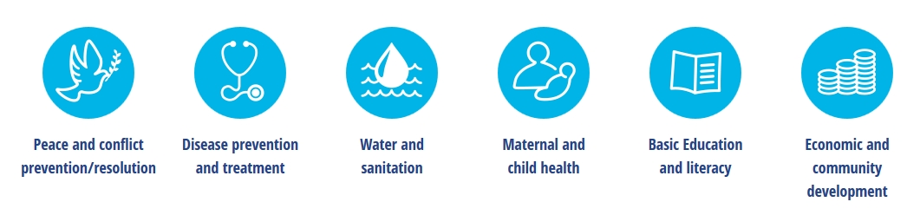

#1 Membership
Membership Goal:
By When:
Strategy |  |  | Time Frame | Measurement | Responsible

#2 Service and Fundraising
Goals | Time Frame | Measurement | Responsible

#3 Foundation and Polio Plus
Goals | Time Frame | Measurement | Responsible

#4 Public Image
Goals | Time Frame | Measurement | Responsible

#5 Fellowship
Goals | Time Frame | Measurement | Responsible

#6 Organizational Readiness
Goals | Time Frame | Measurement | Responsible

Rotary Core Values
Fellowship | Integrity | Diversity | Service | Leadership

Rotary Vision Statement
Together, we see a world where people unite and take action to create lasting change – across the globe, in our communities, and in our selves.

Rotary Mission Statement
We provide service to others, promote integrity, and advance world understanding, goodwill, and peace through our fellowship of business, professional, and community leaders.

